Environment Impact assessment (EIA)

- EIA is a tool for decision-makers to identify potential environmental impacts of proposed projects, to evaluate alternative approaches, and to design and incorporate appropriate prevention, mitigation, management and monitoring measures.

- Environmental impact assessment cannot be divorced from social impact of the project, hence the latter is considered as a key dimension of the EIA process, e.g. land tenure and rights, rural livelihoods, and traditional practices.

In principle, environmental assessment can be undertaken for
- Individual projects such as a dam, motorway, airport or factory and call it as 'Environmental Impact Assessment' (EIA).
- Plans, programs and policies and call it as 'Strategic Environmental Assessment'(SEA).

- EIA focuses on problems, conflicts or natural resource constraints that could affect the viability of a project.
- It also examines implications of a project that might harm people, their homeland or their livelihoods, or other nearby developments.
- After predicting the problems, a EIA identifies measures to minimise the problems and outlines ways to improve the project’s suitability for its proposed environment.
- EIA has been recognised as the most valuable, inter-disciplinary and objective decision-making tool with respect to alternate routes for development, process technologies and project sites.
Evolution of EIA
- United States of America was the first country to assign mandatory status to EIA through its National Environmental Protection Act (NEPA) of 1969.
- EIA in India was started in 1976-77, when the Planning Commission asked the then Department of Science and Technology to examine the river-valley projects from the environmental angle.
- The Government of India enacted the Environment (Protection) Act on 23rd May 1986.
- To achieve the objectives of the Act, one of the decisions taken was to make EIA statutory.
- A notification was issued on 27th January 1994 and subsequently amended on 4th May 1994, 10th April 1997 and 27th January 2000 making environmental impact assessment statutory for 30 activities.

Besides this, the Government of India under Environment (Protection) Act 1986 issued a number of notifications, limited to specific geographical areas.

- Prohibiting location of industries except those related to Tourism in a belt of 1 km from high tide mark from the Revdanda Creek up to Devgarh Point (near Shrivardhan) as well as in 1 km belt along the banks of Rajpuri Creek in Murud Janjira area in the Raigarh district of Maharashtra (6th January 1989).
- Restricting location of industries, mining operations and regulating other activities in Doon Valley (1st February 1989).
- Regulating activities in the coastal stretches of the country by classifying them as coastal regulation zone and prohibiting certain activities (19th February 1991).
- Restricting location of industries and regulating other activities in Dahanu Taluka in Maharashtra (6th June 91).
- Restricting certain activities in specified areas of Aravalli Range in the Gurgaon district of Haryana and Alwar district of Rajasthan (7th May 1992).
- Restricting industrial and other activities, which could lead to pollution and congestion in the North West of Numaligarh in Assam (July 1996).

Environmental categories for field projects (FAO)
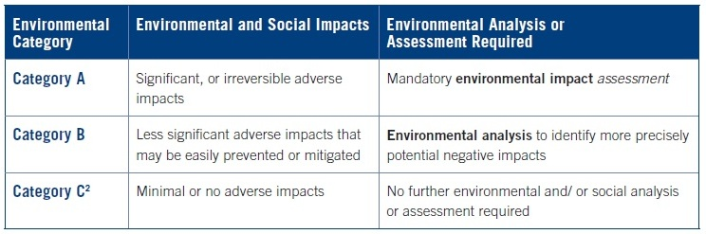
Environment
Indicative list of types of projects under Category A
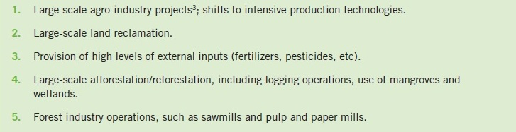
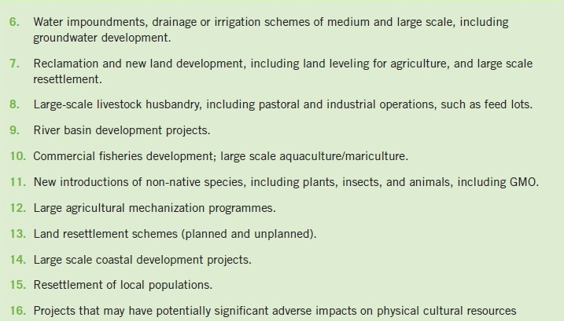

Indicative list of types of projects under Category B
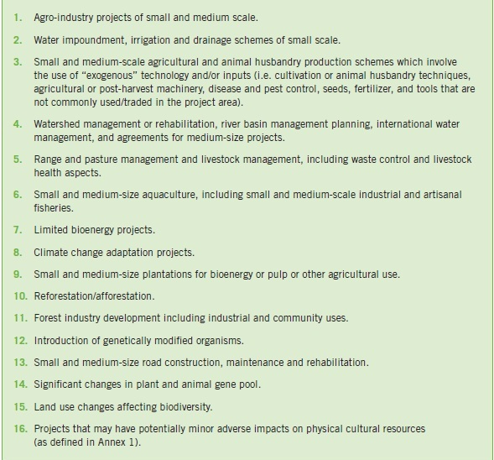

Overview of the EIA process

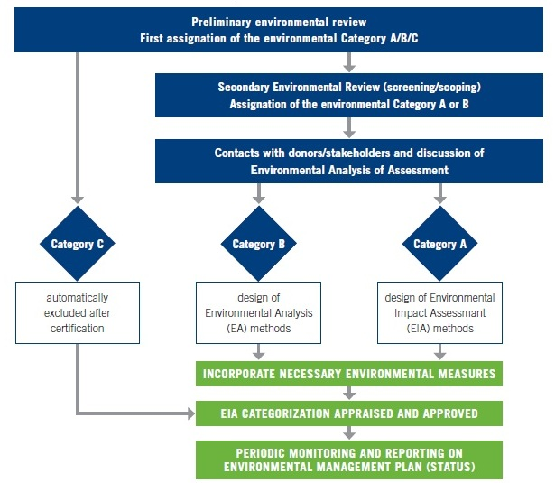

Steps in EIA process

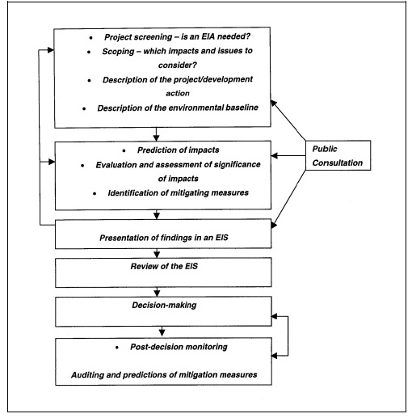

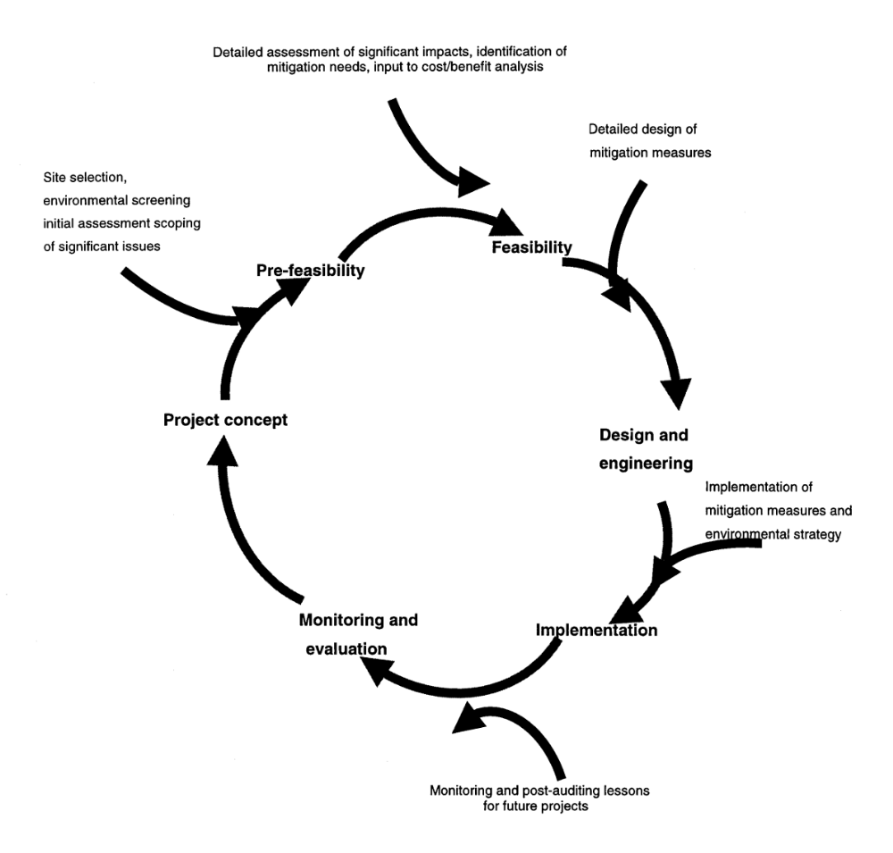
EIA Cycle

